Virtual Private Cloud (VPC)

1. **Understanding VPC**:

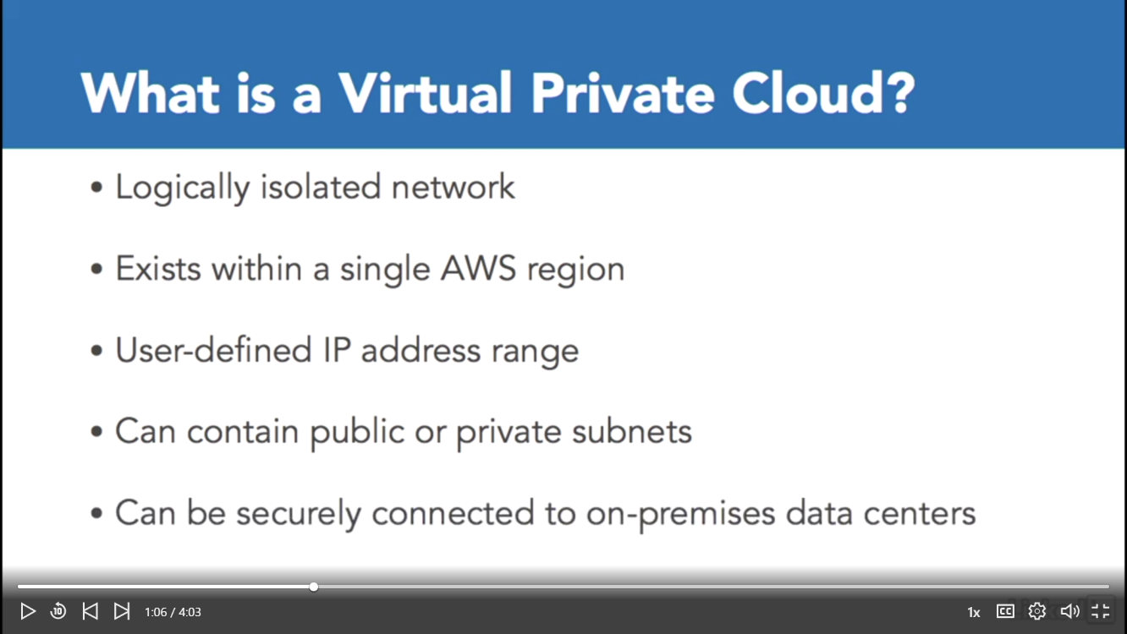

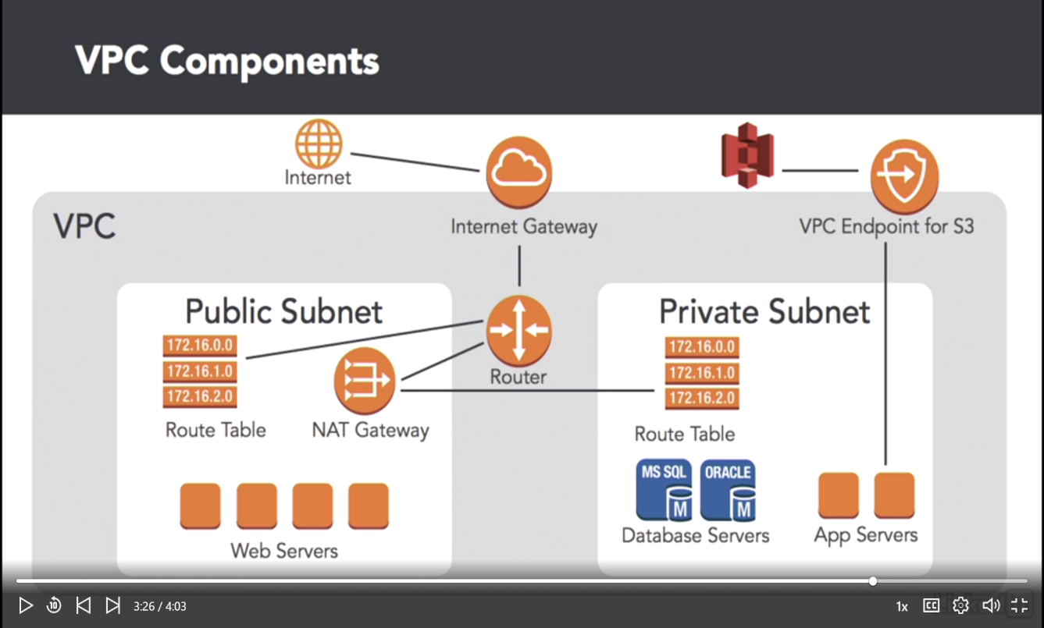

* A VPC is a network container in which you can place all of these components complete with all the tools you need to granularly define network access.
* Let's take a closer look at the VPC components you need to let your web servers be publicly accessible while keeping your app and database servers private.
* To set this up, you need a VPC with two subnets. The first subnet would contain private application and database servers. And the second would contain your public facing web servers.
* In order to let servers within these subnets communicate with each other, you'll need to configure a **router**. Just like a physical router you may have worked with, a router in AWS directs traffic between subnets.
* To get to the internet, you will need to configure an **internet gateway**. And internet gateway is a highly available VPC component that connects a VPC to the internet. In order to be able to patch the servers in your private subnet, they will need to initiate a connection to the internet.
* On premises, you are probably accustomed to configuring network address translation, or NAT. AWS makes this a little easier by offering a **NAT Gateway**. A NAT Gateway is a highly available service for allowing private subnets to access the internet.
* Of course, to make this all work, you will need to configure the **route tables** for each of your subnets appropriately. **The route table in your public subnet needs to be point to the internet gateway. Similarly, the route table in your private subnet needs to point to the NAT Gateway in your public subnet.**
* Finally, you can setup a **VPC endpoint for S3**. This is useful if you want communication between the services within your VPC to access S3 privately without traversing the public internet.
* **VPC represents a logically, private data center in AWS.**
* **You should also identify that an internet gateway is what you attach to a VPC so the systems within the VPC can access the internet.**
* **You should also recognize the need to update the route tables inside you VPC to point to an internet gateway for internet access.**
* **Finally, you should understand that in order for servers in a private subnet to access the internet, you need to configure a NAT Gateway.**

1. **Establish private connections**

